1.Pwd :present working directory lets us know about which directory we are in.
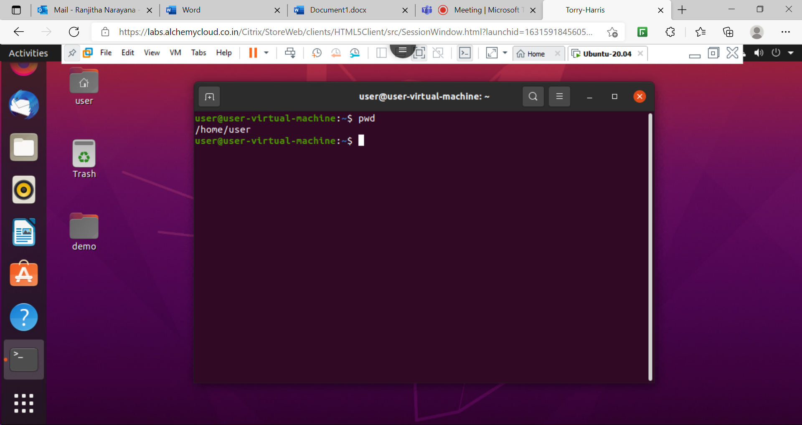

2.ls command:This command is used to display all the directories and file in current directory.

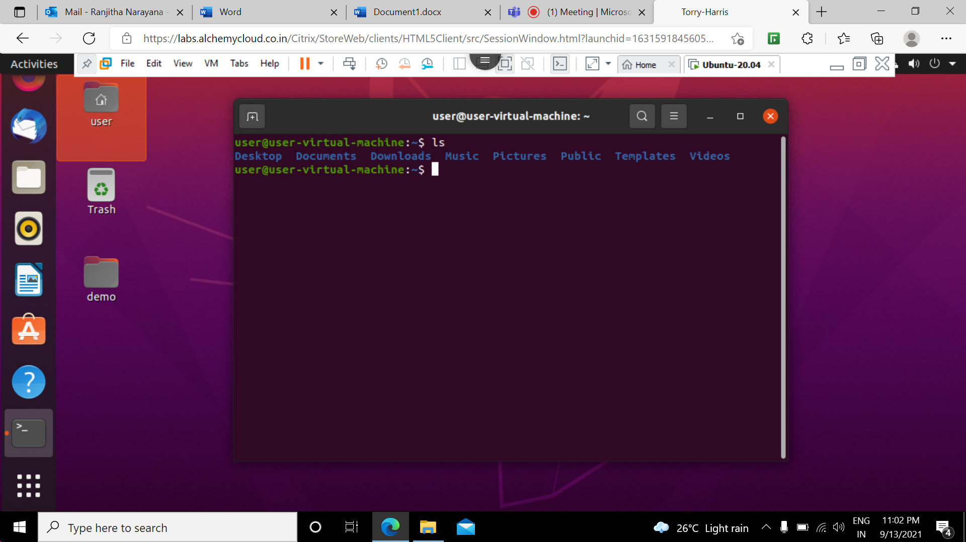

3.ls -l command: shows the list of all the folders in long format and also shows the permissions.
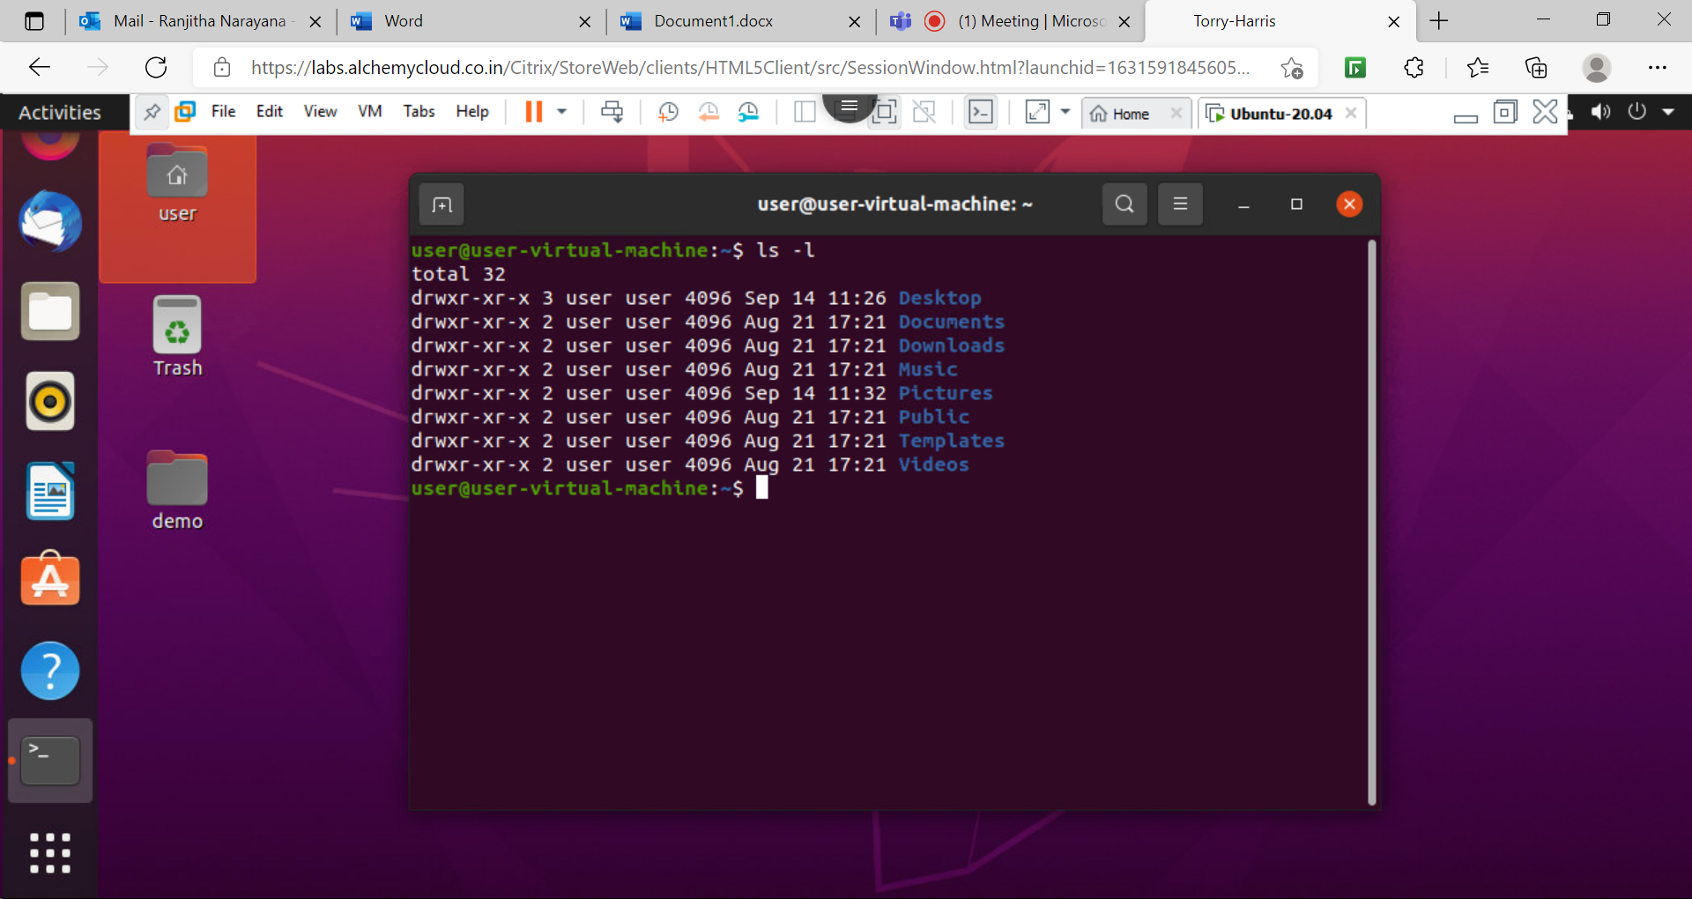

4.ls -a command: used to list all the files including hidden files.
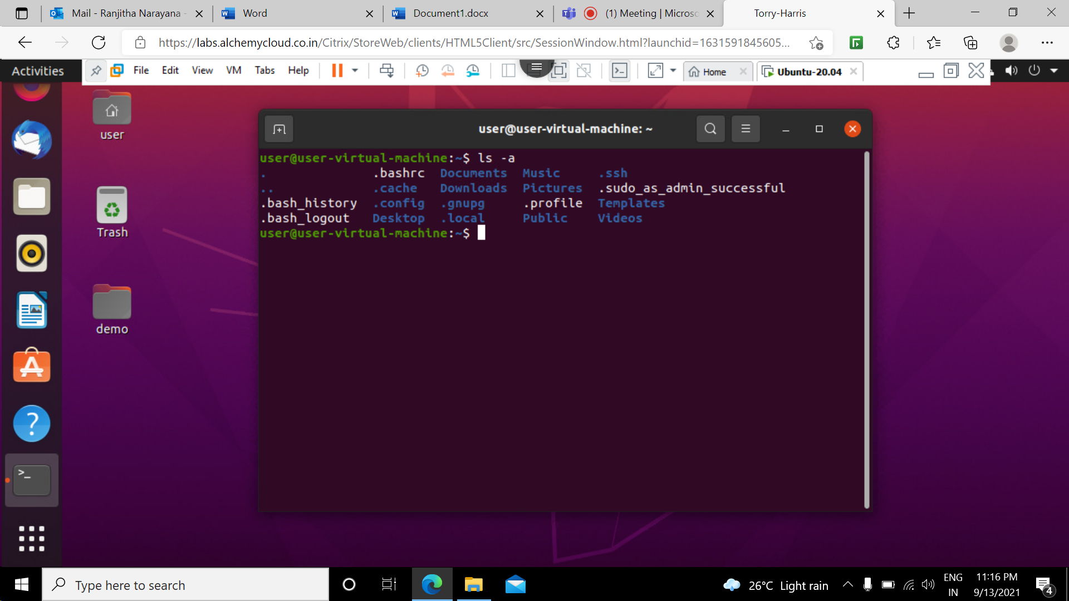

5.ls -A command: this command is used to ignore the two hidden files(. And ..) and showing rest of the other files.
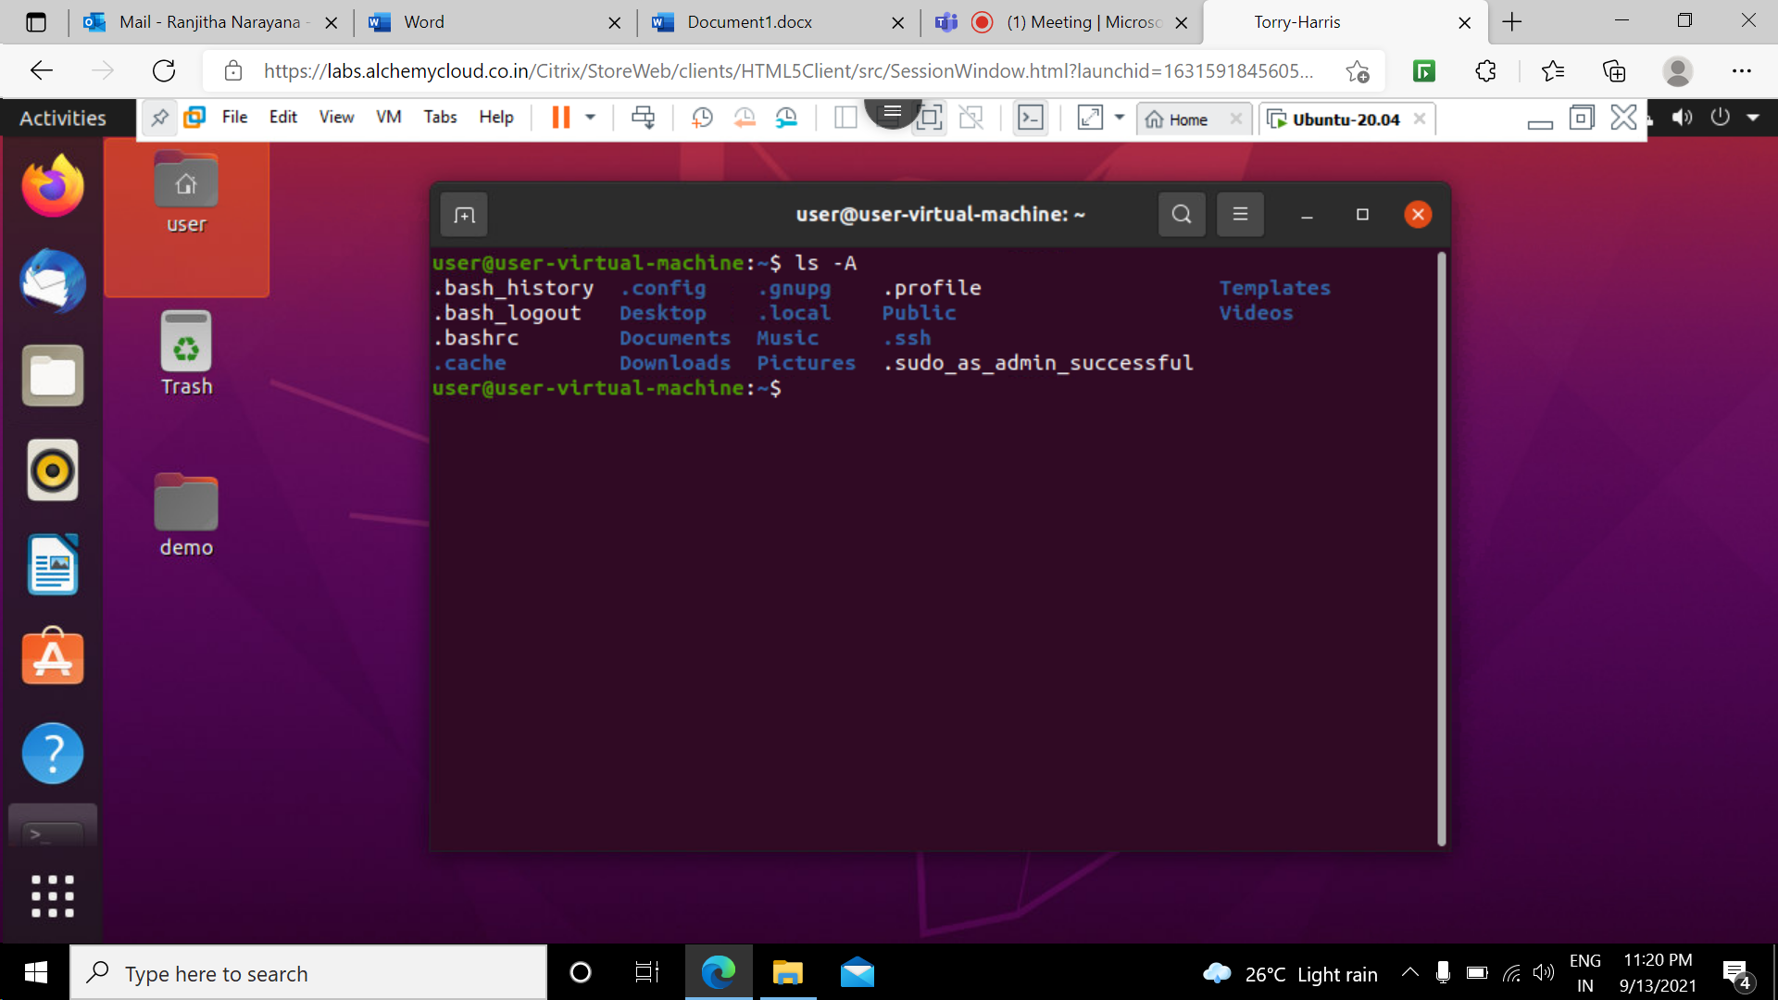

6.ls -f command: this command displays all the folders without any format.
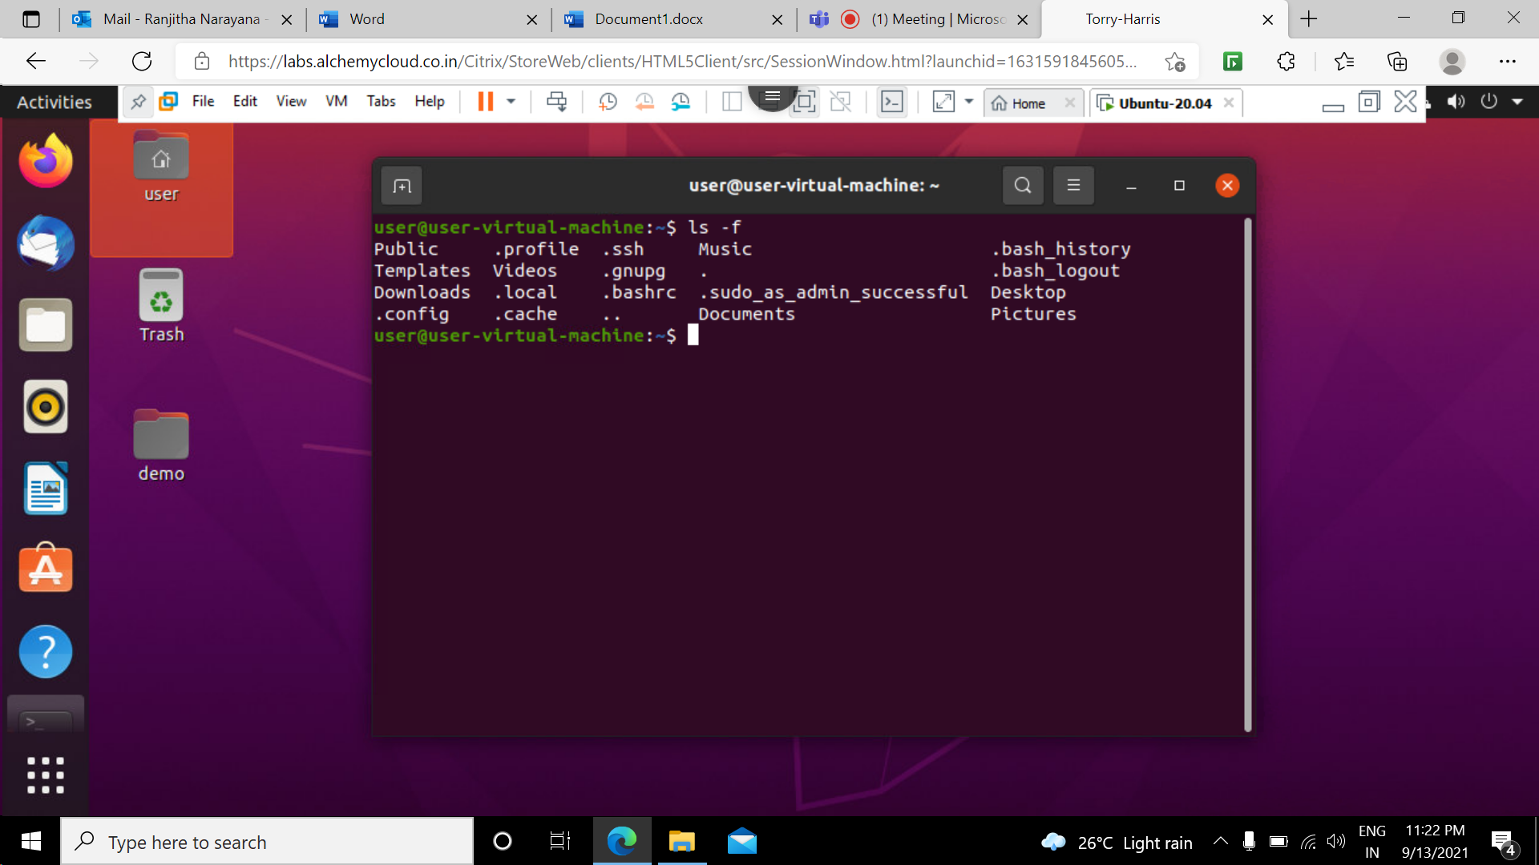

7.man command: used to display the user manual of any command that we can run on the terminalor used to display the documents.
man -ls
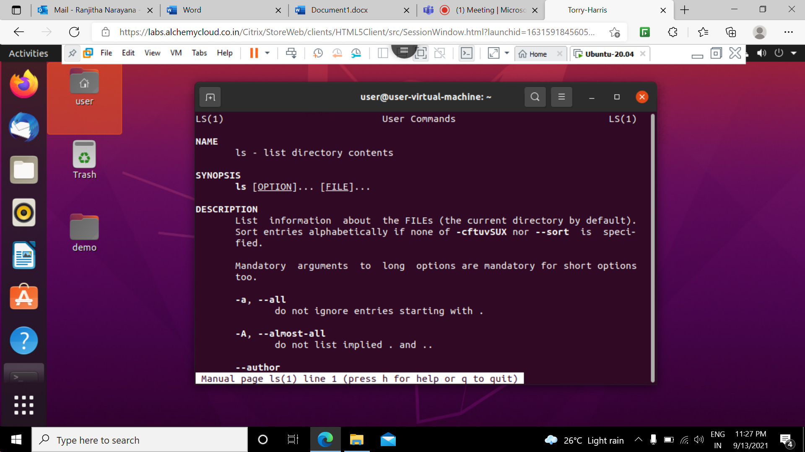

8.Cd command: change directory command is used to change the current working directory.
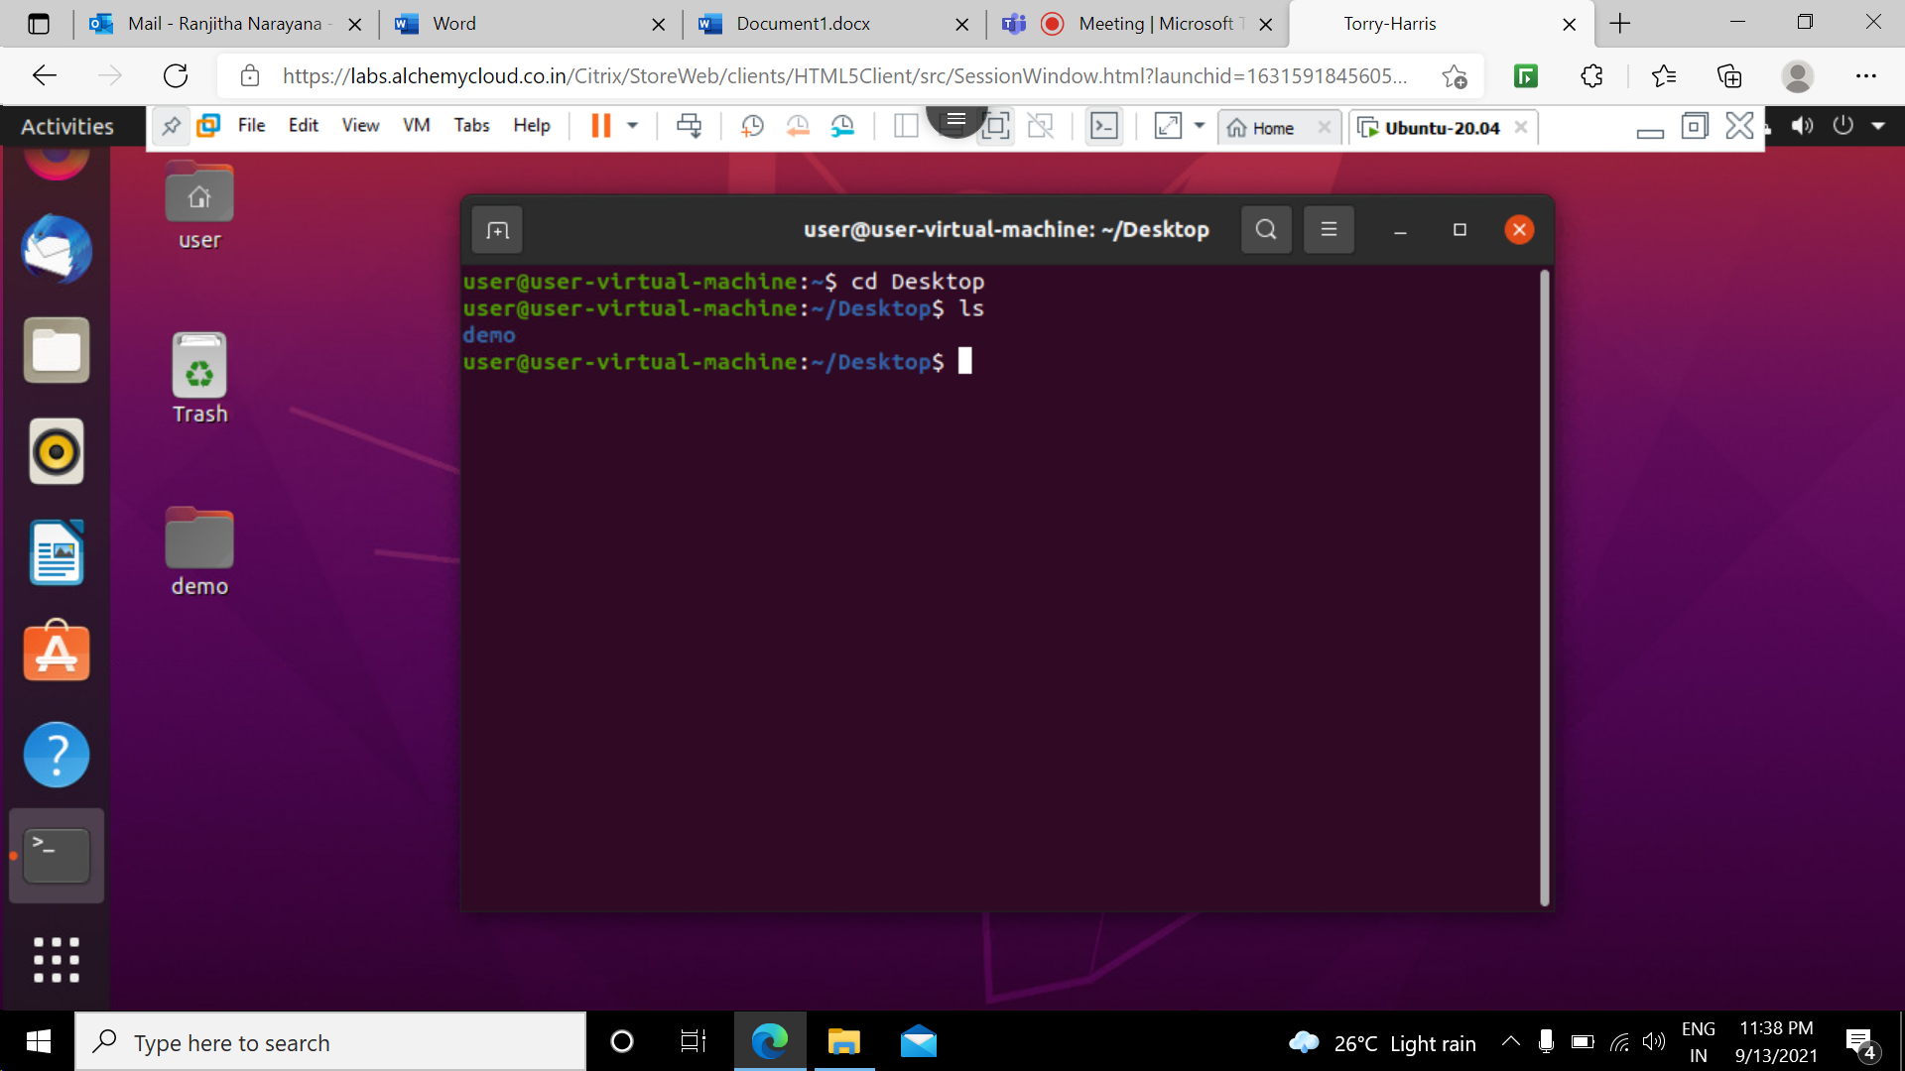

9.echo command: Used to display line of text or string . This command is mainly used in shell scripts.
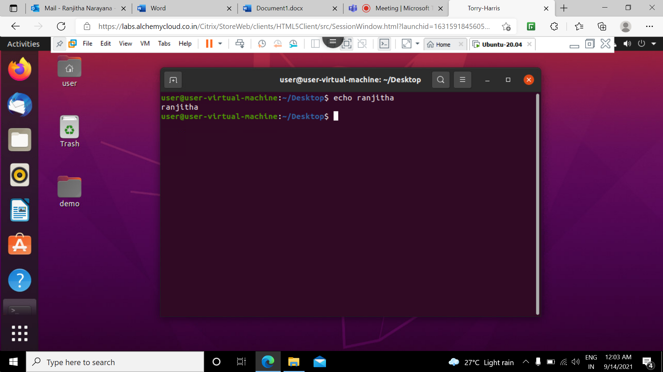

10. echo $PATH command: used to display the current path and used to find the directories our shell is set toncheck for executable files.
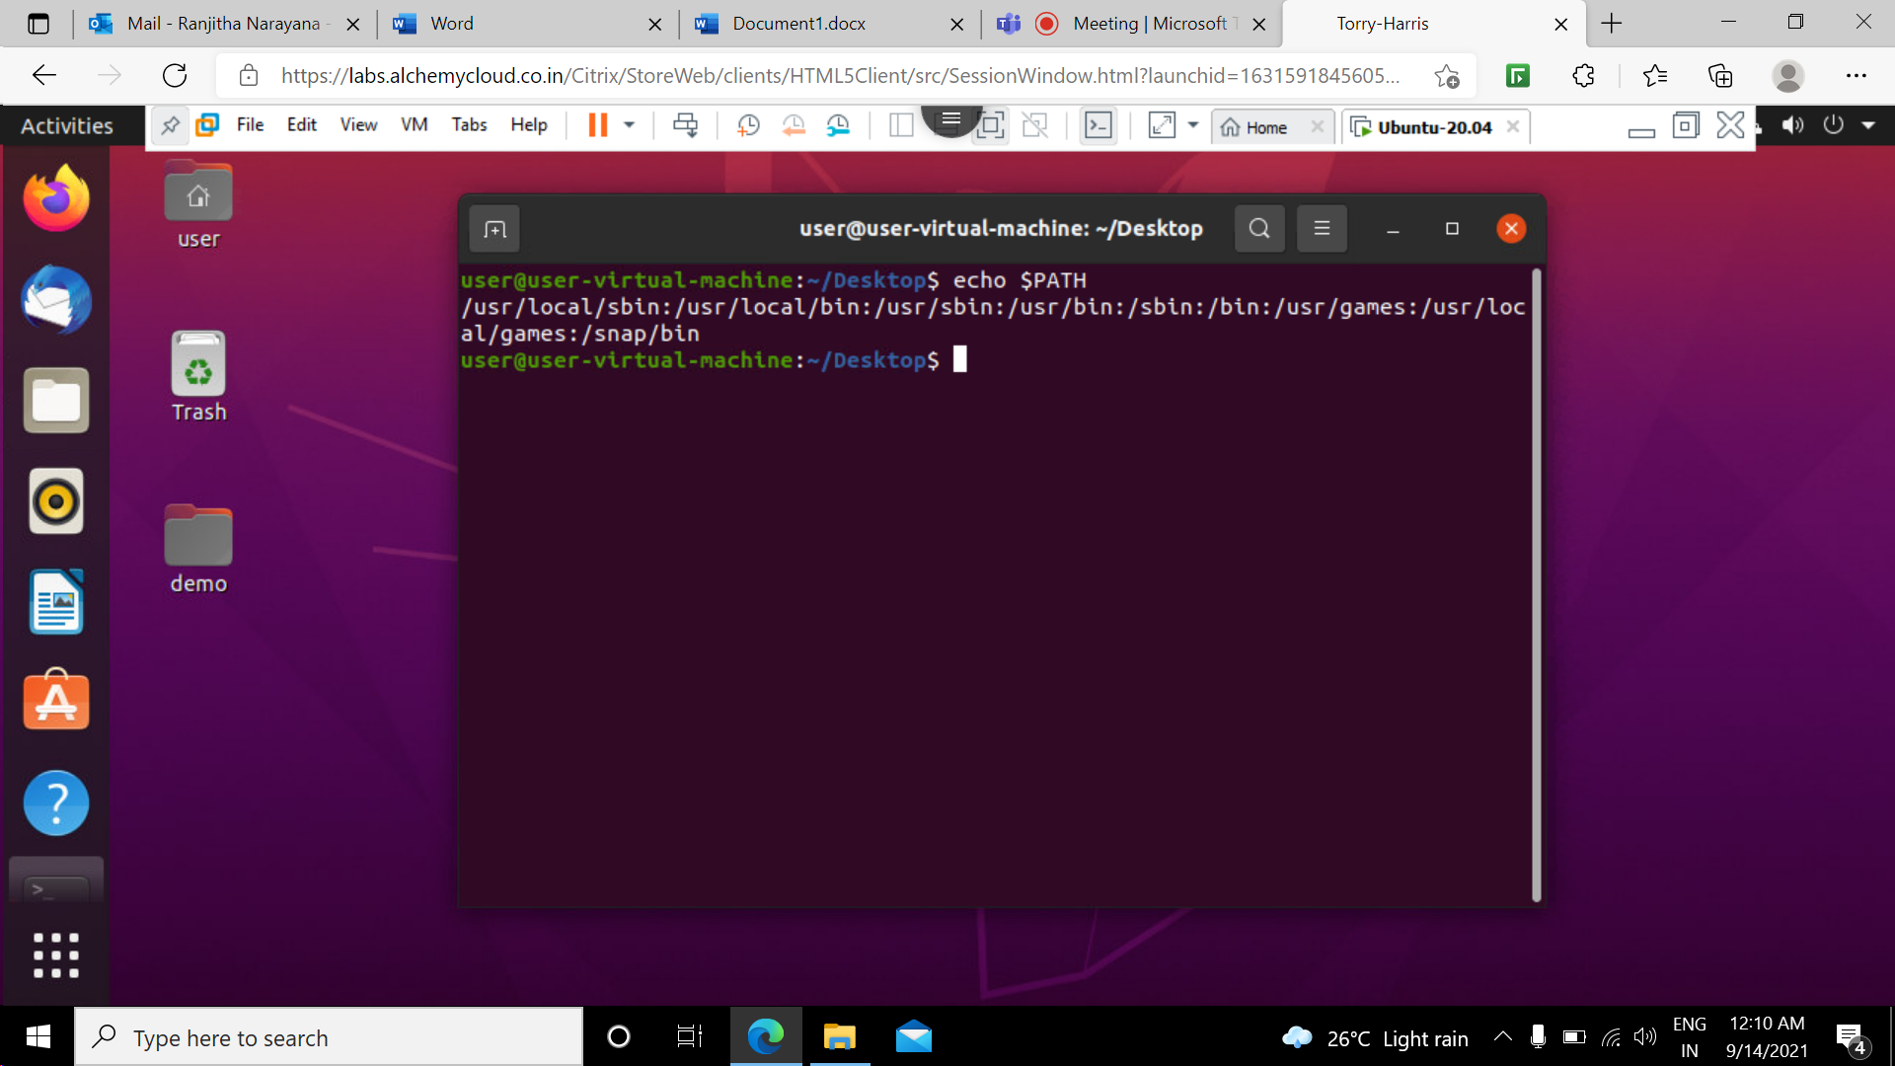

11.rm command: This command is used to remove the files and directories .
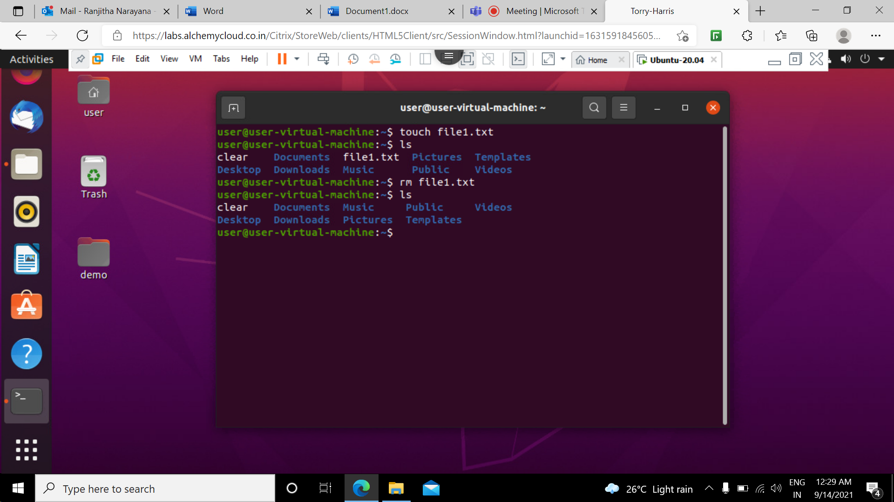

12 rmdir:To remove directory we have to use rmdir command
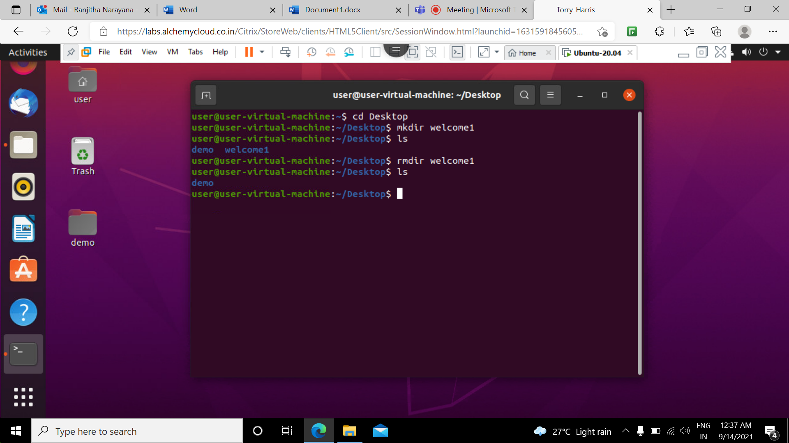

13 who command: displays the users currently logged into the linux os .This command gives the information about time of last system boot,login name,date and time, and list of users logged .
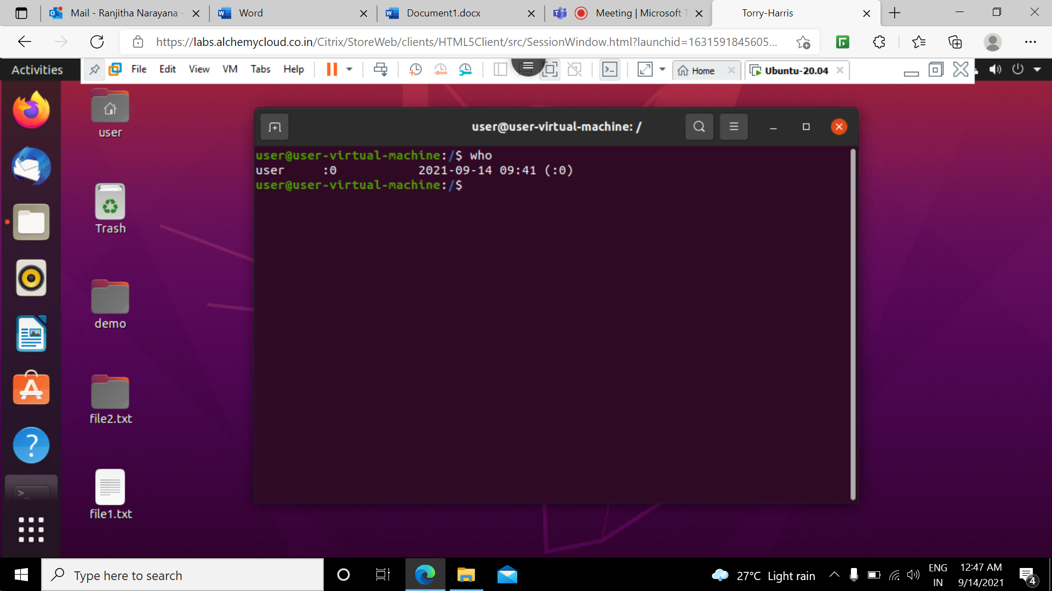

14 date command: used to display the system date and time.
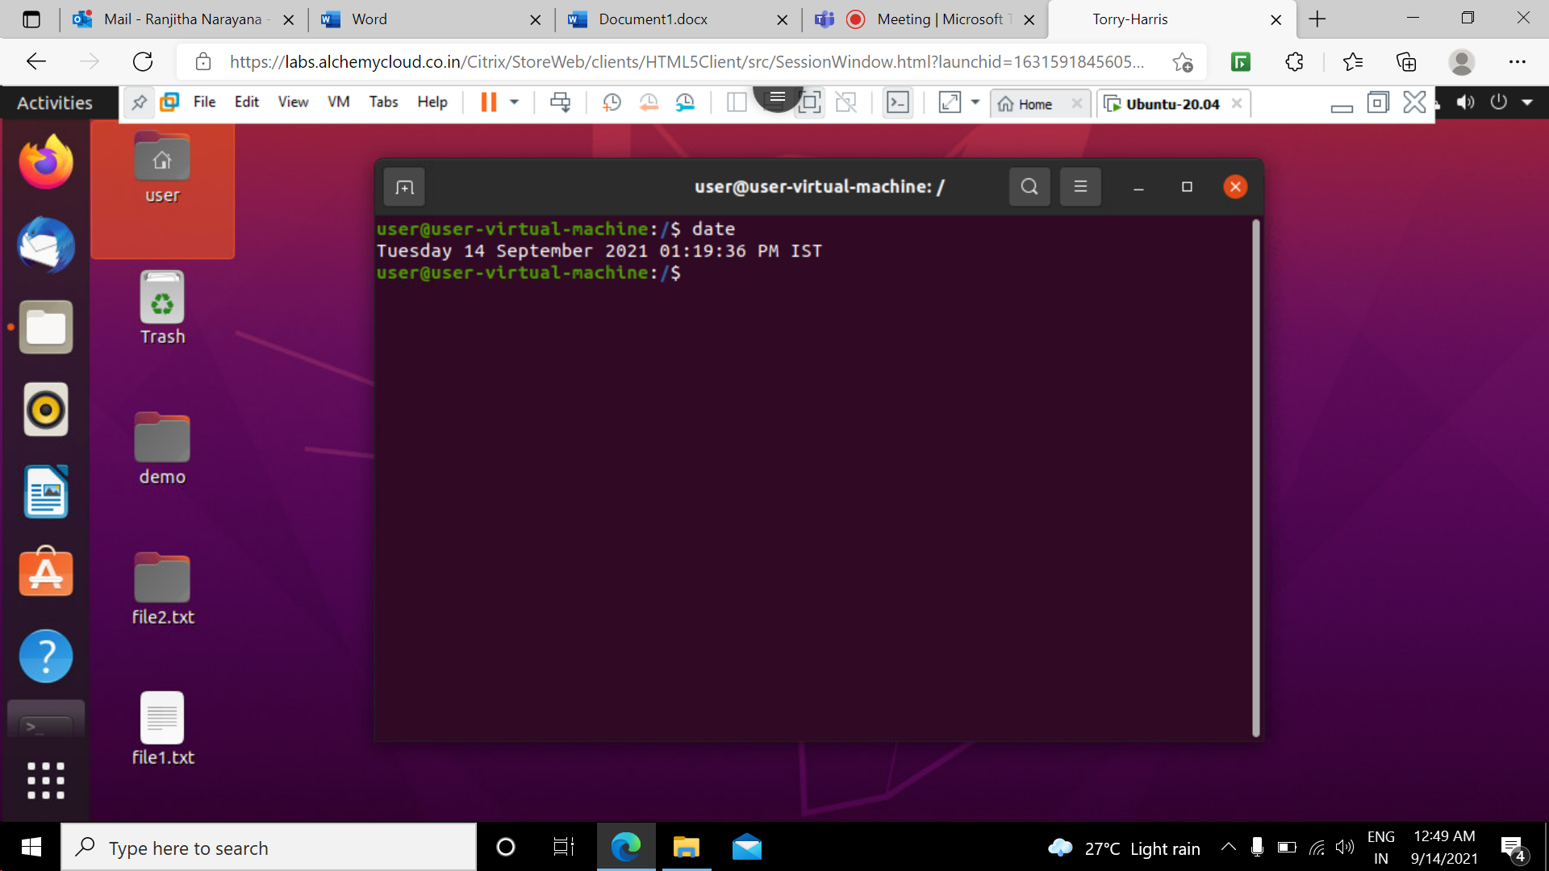

15 cal command: calender command is used to see the calender of a specific month or whole year.
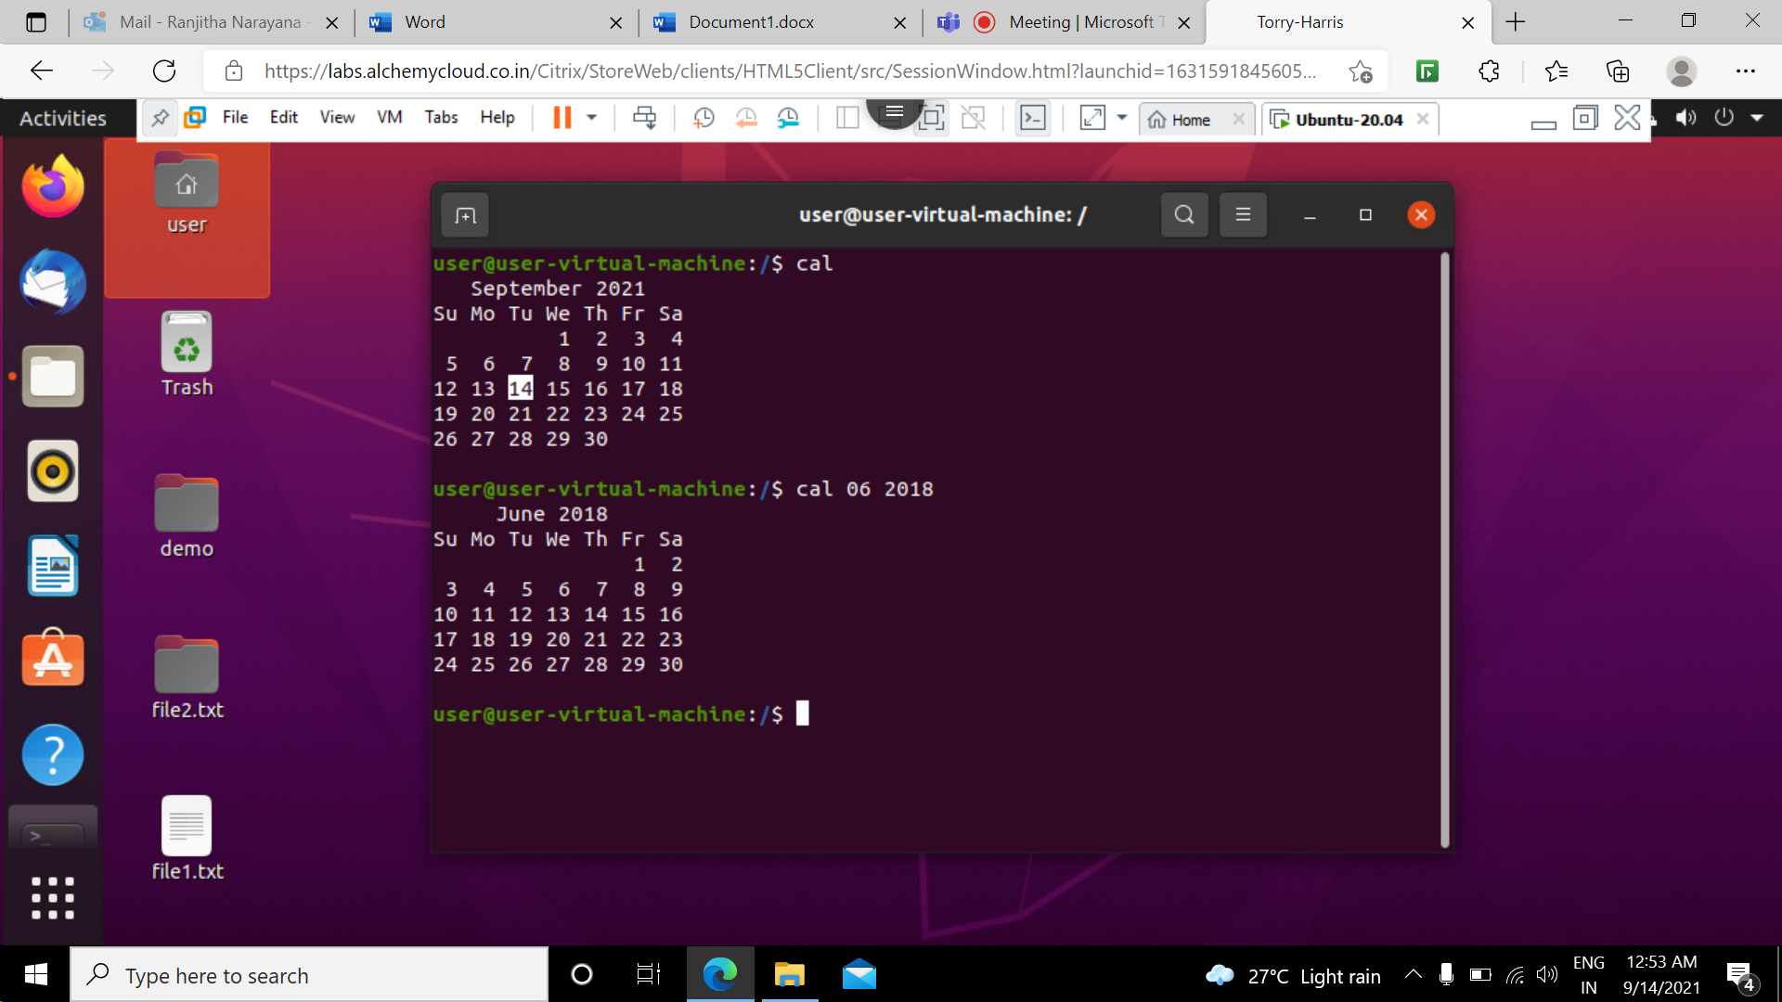

16 mv command: mv stands for move this command is used to move one or more files or directories from one place to another in a system and it is also used to rename a file or folder.
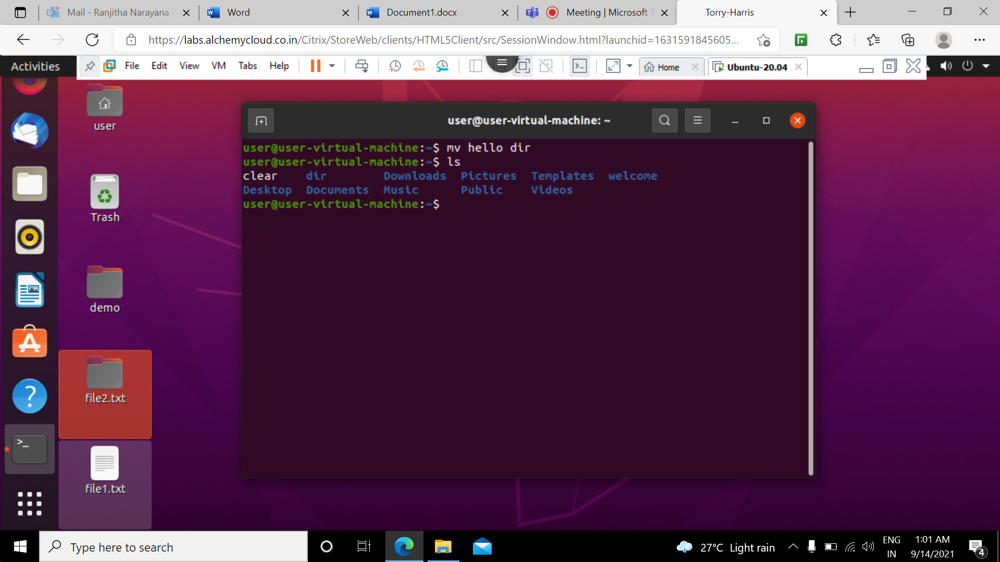

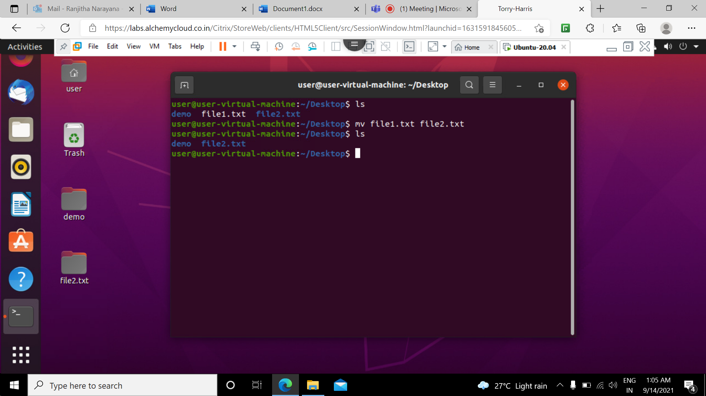

17 cp command: stands for copy .this command is used to copy files or directories
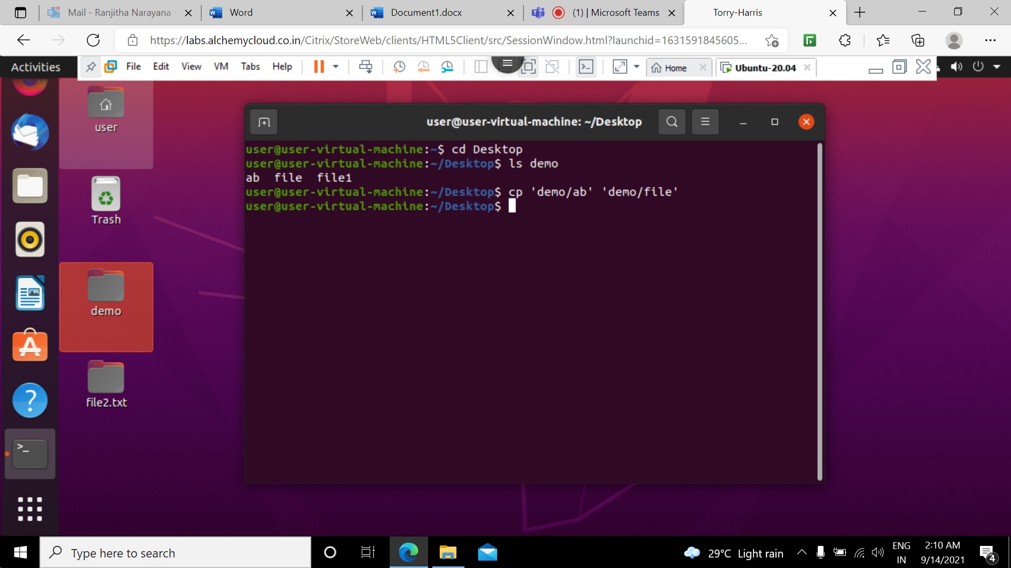

18 mkdir command: allows the user to create new directory inside an existing working directory.
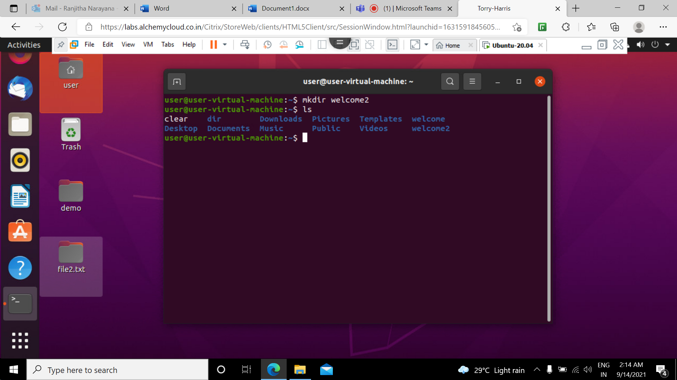
19 passwd command: Used to change the current user account passwords.
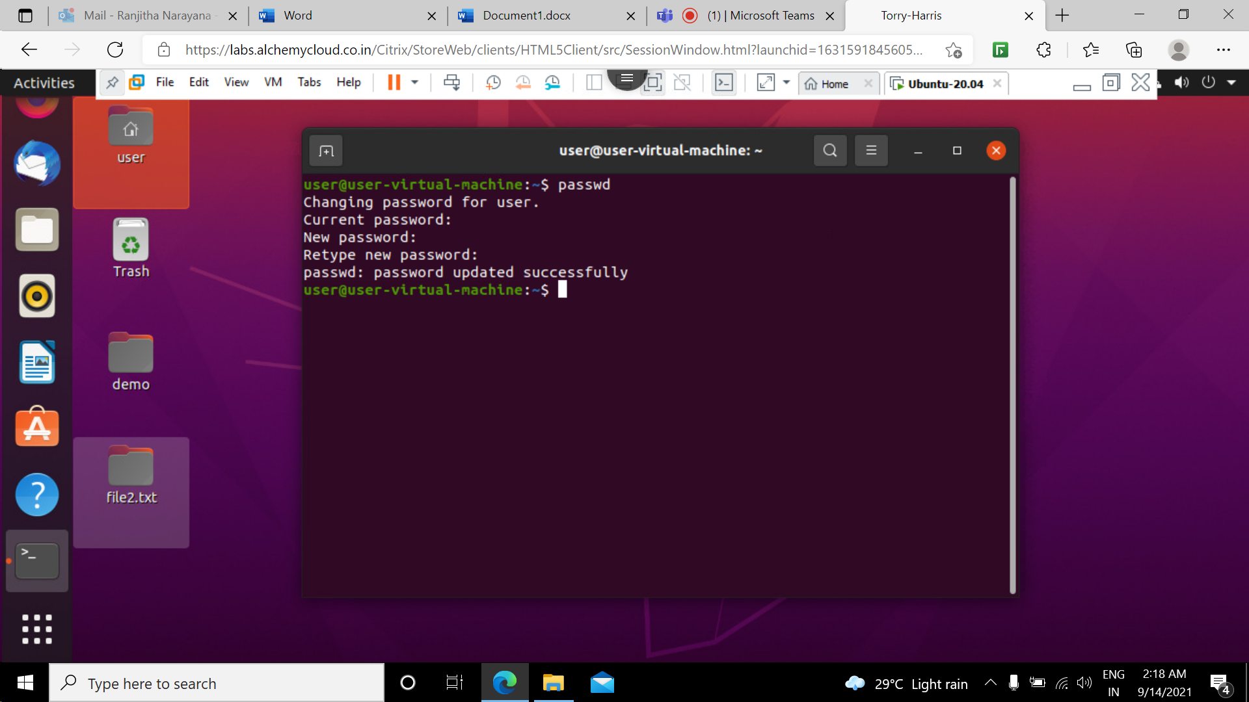

20 tree command :The tree command is used to list out the contents of directories in a tree like fashion.
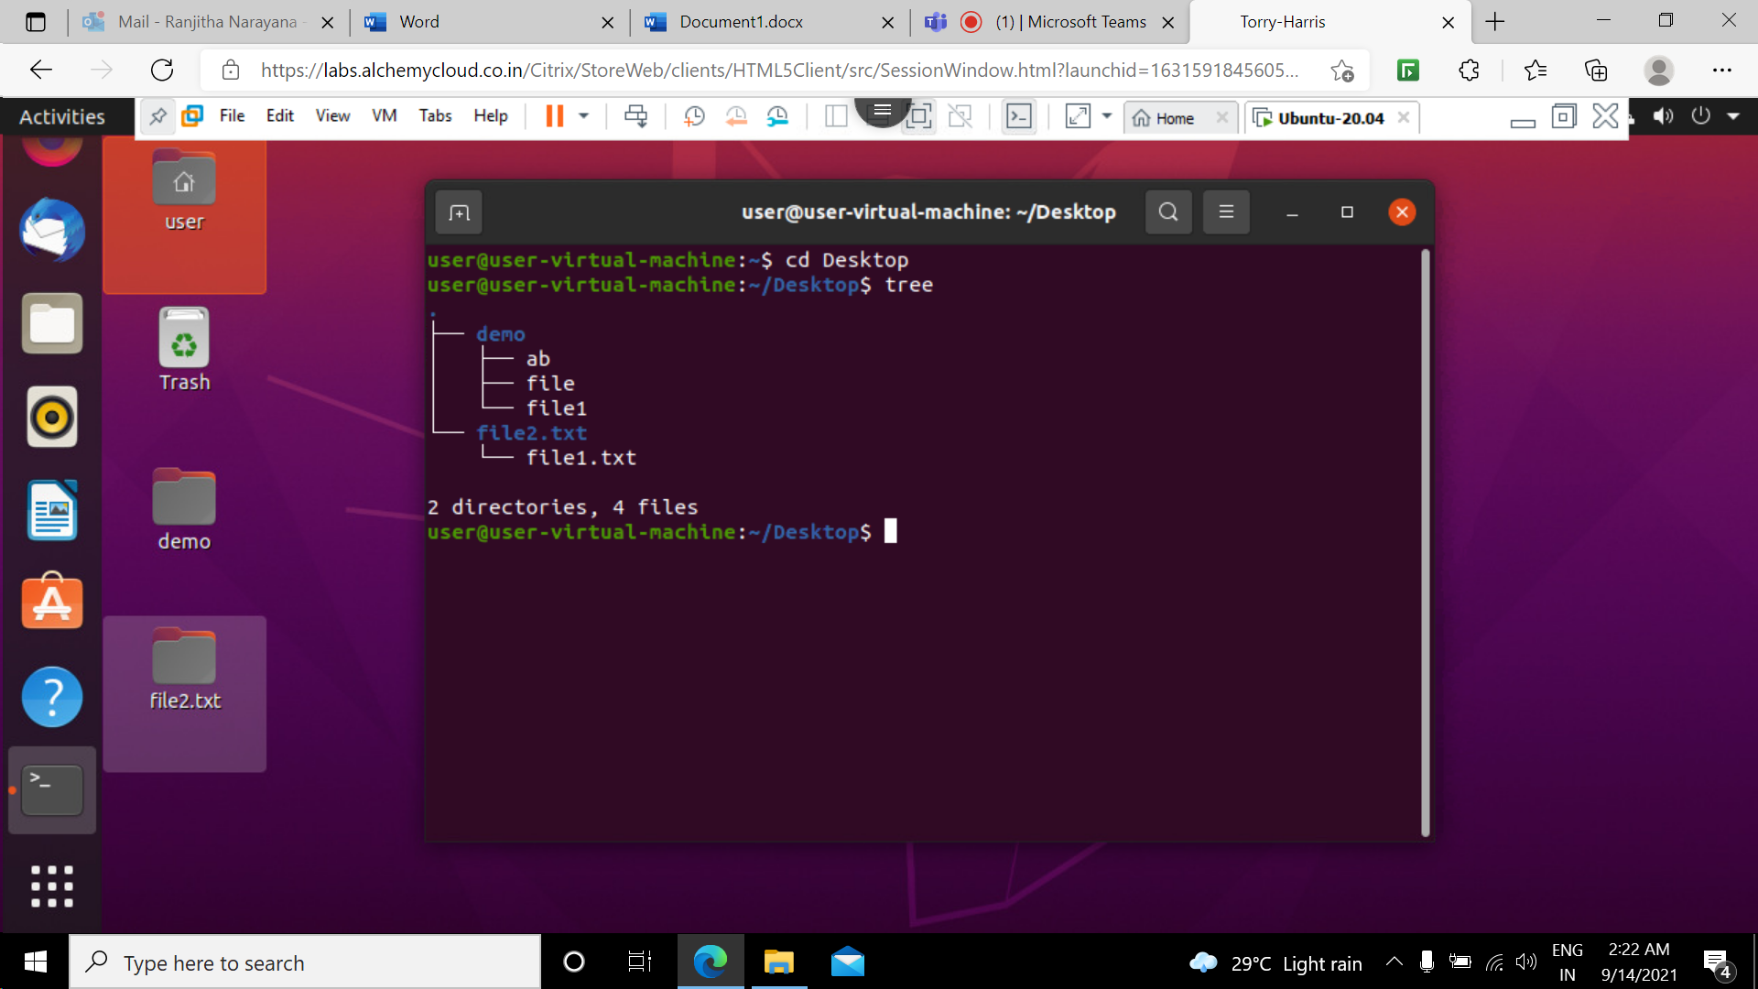

21 tree -d command: this command is used to list directories only.
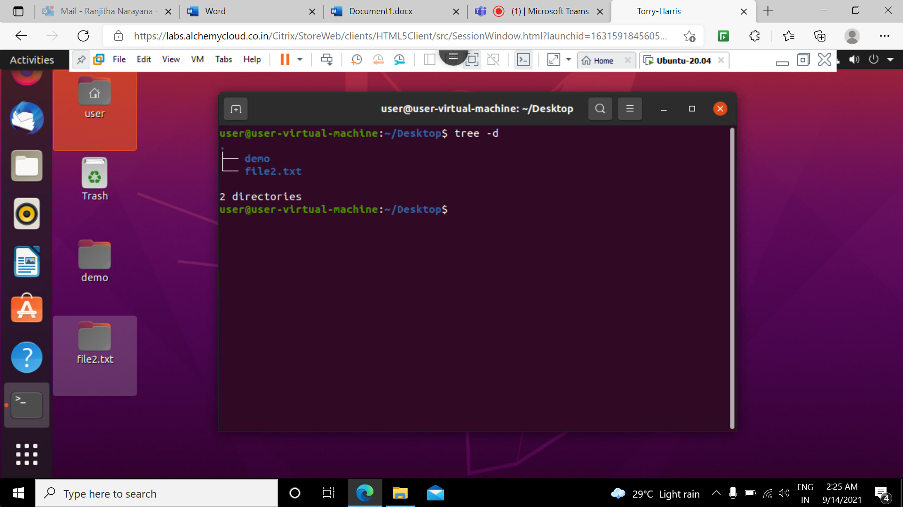

22 tree -- version command : This command outpputs the tree version.
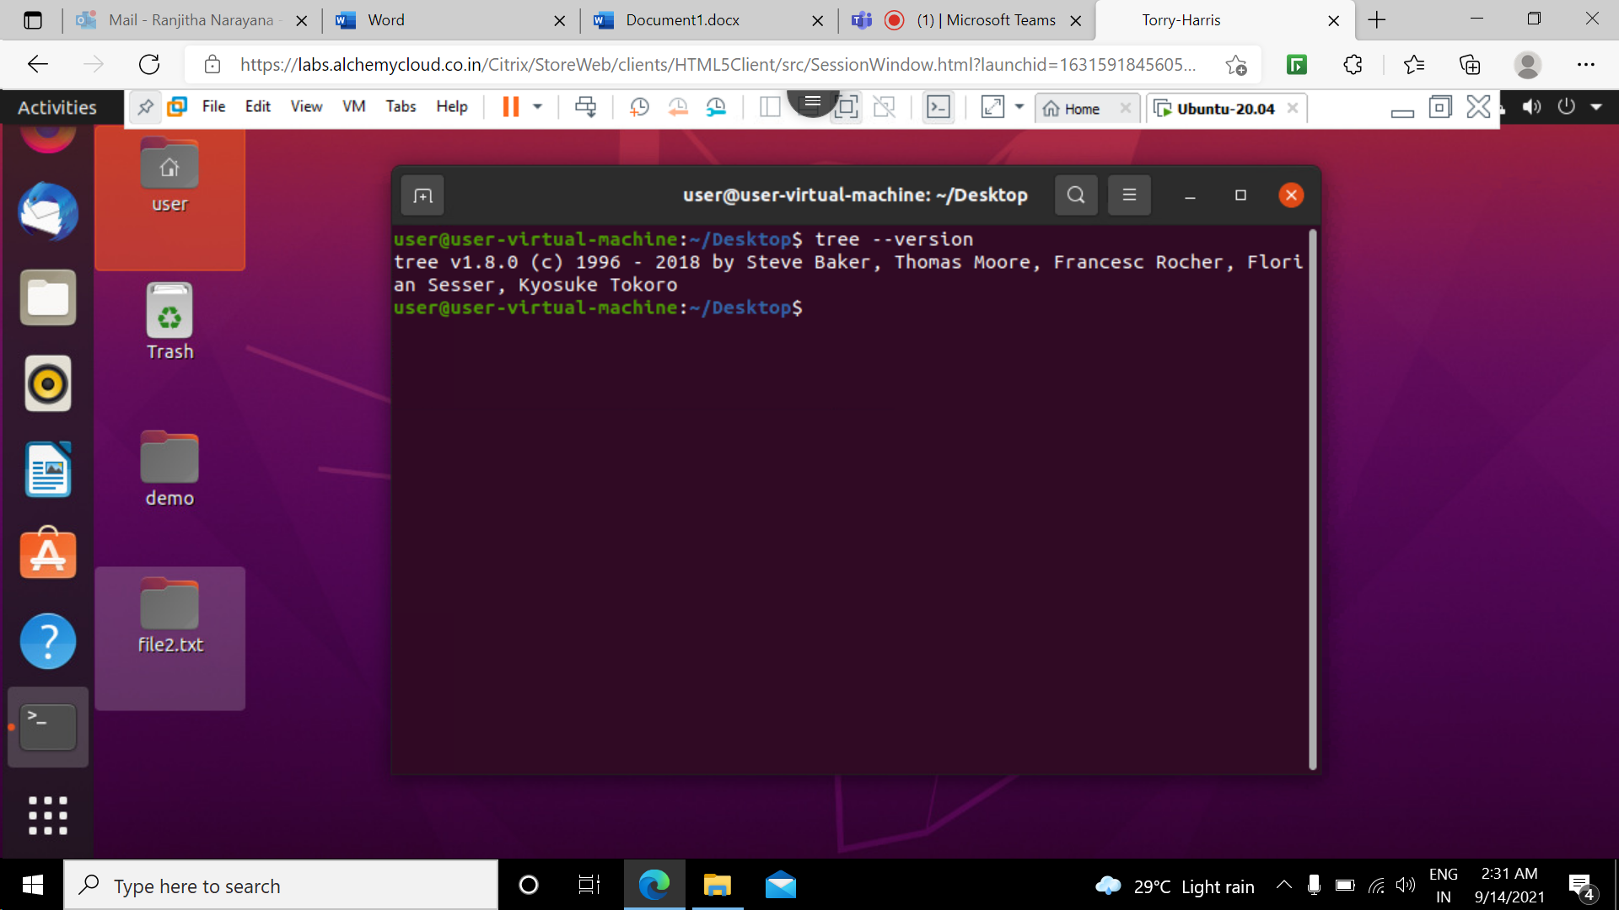
23 tree --help command: This command is used outputs a verbose usage listing.


